

Research Officer’s Annual Report

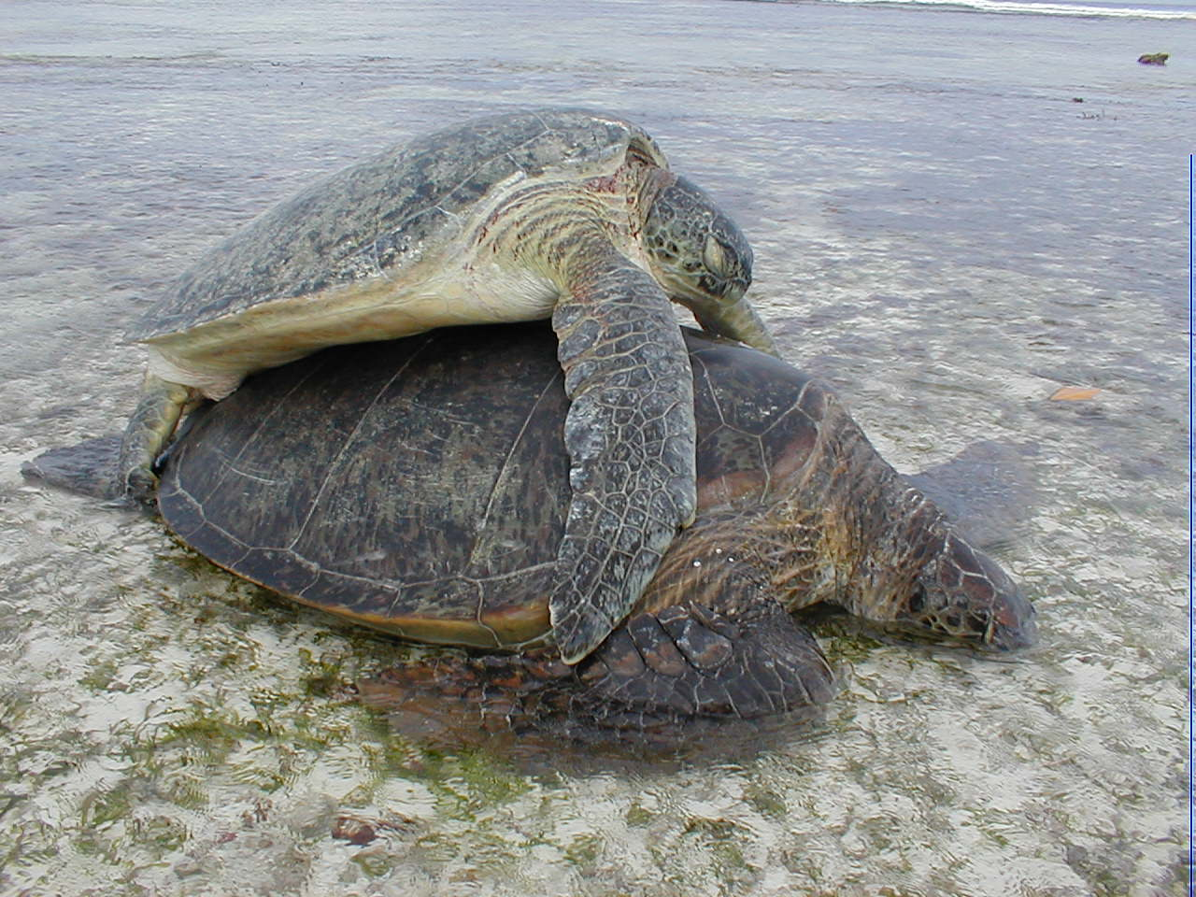

January to November 2003

Compiled by: Rainer von Brandis

